Direct Address Table.
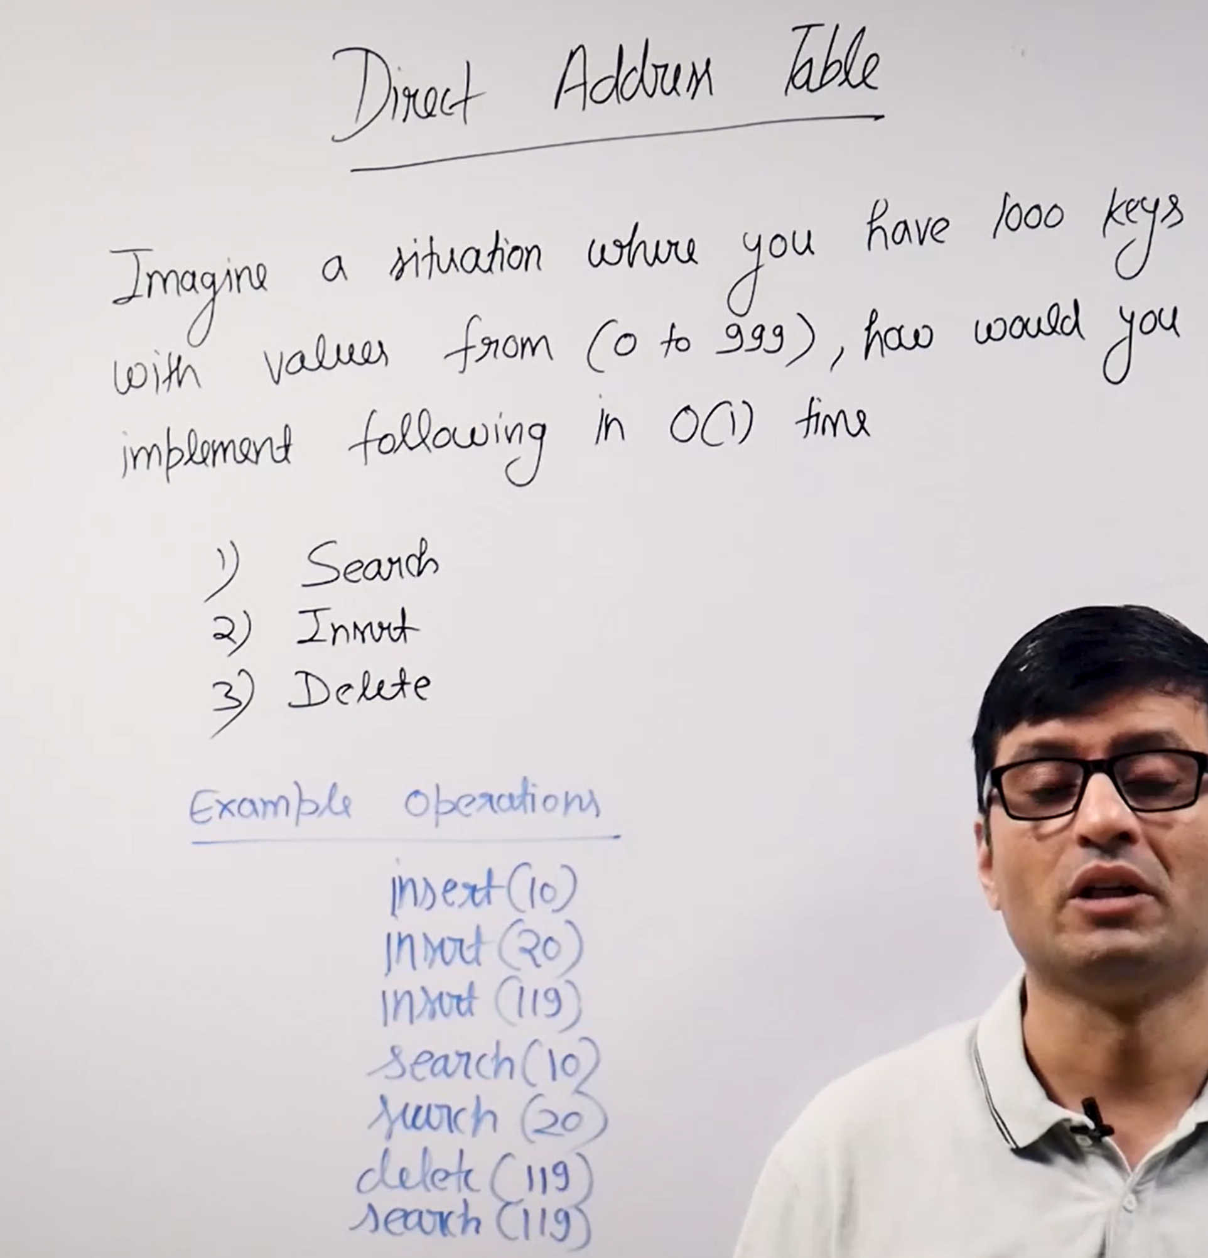
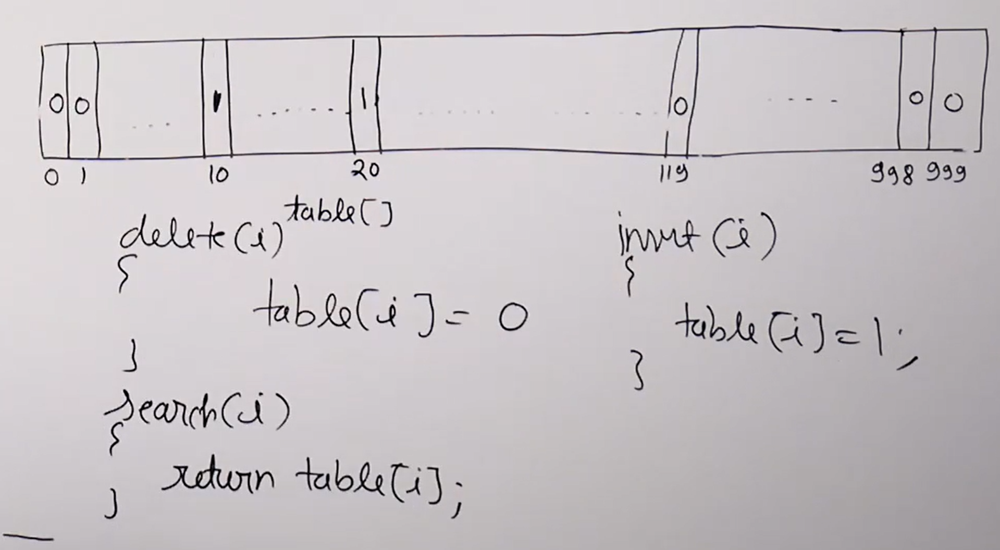
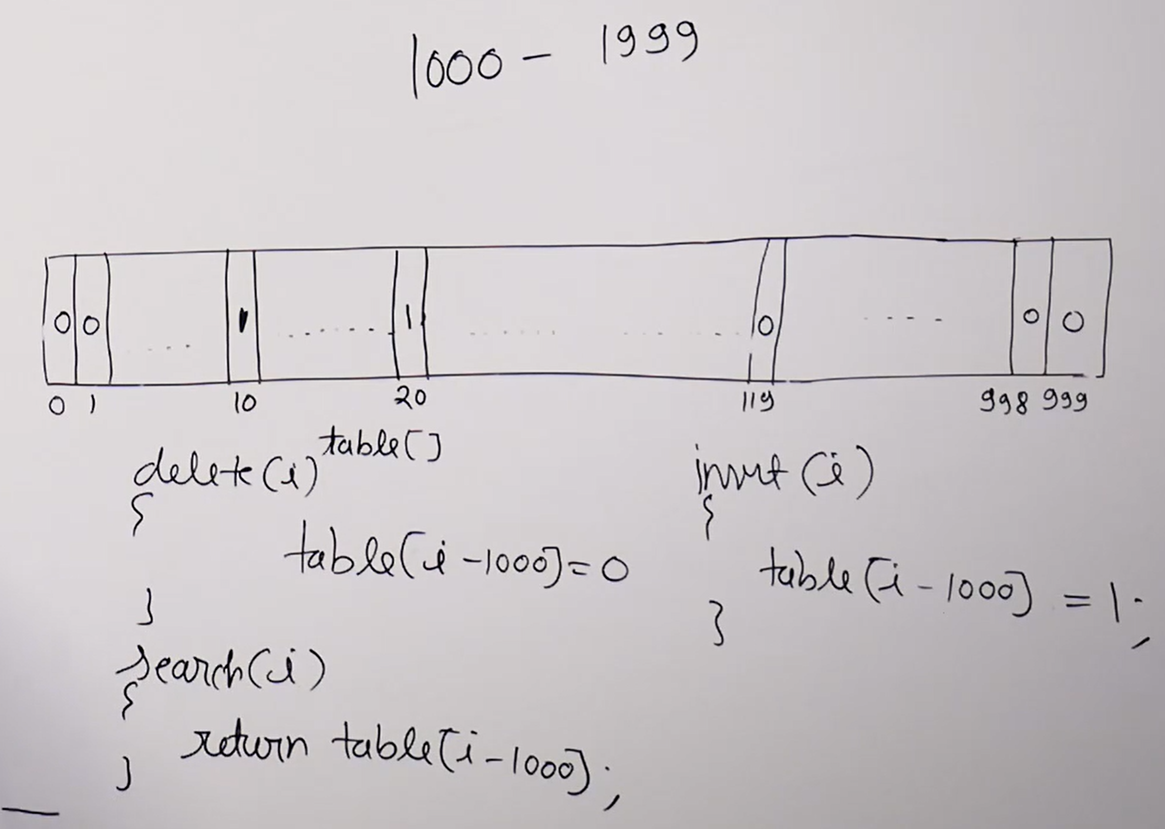

Problems with the direct Address table?
- It doesn’t handle the large values.
- It doesn’t handle floating point numbers
- It doesn’t handle string or address (combination of numbers and strings)
For this only the hashing came into picture.
direct index table and the direct address table both are same.

